

Eionet Forum administration manual

Prepared by
Miruna Bădescu, Andreea Teodorescu
May 2011
Version 1.1
User guide
Version management
No | Date | Changes | Author
1.0 | 04/04/11 | First version | Miruna Bădescu
1.1 | 05/05/11 | Updated some screenshots, updated the file object | Andreeea Teodorescu

Contents
1. Setting the scene 4
2. Terms, abbreviations and acronyms 4
3. Eionet Forum overview 5
3.1. Definitions and concepts 5
3.2. Eionet Forum interface 5
4. Naaya overview 6
4.1. Extensibility 7
4.2. Modularity 7
4.3. Levels of administration 8
5. Content management 10
5.1. Content types 10
5.2. Folder-level 20
5.3. Interest Group administration 23
6. Translate the website 25
6.1. The language negotiation process 26
6.2. Multilingual content 26
6.3. Multilingual interface 28
6.4. Multilingual searches 30
6.5. Multilingual syndication 30
7. Change the layout 31
7.1. Portlets administration 32
8. Users and roles 34
9. Discussion forum 37
10. The survey tool 38
10.2. Taking the survey 43
10.3. Analysing the results 43
11. TalkBack consultation tool 44
12. Photo gallery 47
13. References 51

Setting the scene
This document describes the content management and maintenance operations that an administrator of a Naaya portal for the Eionet Forum can perform.
Currently, the Eionet Forum is hosted on the EEA servers at:
- http://forum.eionet.europa.eu
An application for creating a new Interest Group on the Eionet Forum can be made here: http://forum.eionet.europa.eu/applications.
All Naaya source code can be found on the EEA source repository https://svn.eionet.europa.eu/repositories/Naaya/
Further details on Naaya installation issues do not fall into the subject of this guide, they are included in the Naaya installation instructions.
Throughout the administration manual, it may be that Interest Groups would be referred to as Naaya portals or websites.

In the following, the assumption is that an Interest Group on the Eionet Forum has been created and you have administrative rights on it.

Terms, abbreviations and acronyms

Term | Definition
XML | eXtensible Markup Language
CMS | Content Management System
Zope | An open source application server for building content management systems, intranets, portals, and custom applications
ZMI | Zope Management Interface
PTK | Portal ToolKit
Naaya | A Python-based content management system that works under Zope
Eionet | The European environment information and observation network (Eionet) aims to provide timely and quality-assured data, information and expertise for assessing the state of the environment in Europe and the pressures acting upon it. It's a Partnership Network of the EEA and its member and cooperating countries involving approx. 1000 experts and more than 350 national institutions.
IG | Eionet Forum Interest Group
TAL | Template Active Language, a scripting language for Zope
Remote channel | A summary of content published on the Web in XML format and updated on regular basis. Often referred to as “feed”. Content available in this format is parsed by websites, browsers and desktop applications and presented to visitors as listing of contained items (e.g. latest news from related site). Usually, the presence of RSS/RDF/ATOM feeds is signalled on websites using icons such as or .
Portlet | User interface components that are managed and displayed in a web portal. They produce fragments of markup code that are aggregated into a portal page, typically on the left or right sides of the page.
LDAP | Lightweight Directory Access Protocol is an Internet protocol that email and other programs use to look up information from a server. Simplified, it can be compared with an address book.

Eionet Forum overview
The Eionet Forum enables a community (e.g. committee, working group, project group etc.) geographically spread across Europe (and beyond) to have a private space on the Internet where they can share information, documents, participate in discussions and various other functionalities.
This private space is called an "Interest Group" or IG. The access and navigation in this virtual space is done via any Internet browser and as in any working group, committee or project team, one member plays the role of chairman or moderator; in the Forum it is called an IG Leader.

Definitions and concepts
The key definitions and concepts behind the Eionet Forum are:
- Interest Groups: the Forum is organised around Interest Groups (IGs) i.e. a private workspace for a group of people that need to collaborate to achieve common objectives and tasks. Although all IGs have access to the same set of functionalities, the environment is fully customisable for a given IG and the information is restricted to the members of that specific IG.
- Access profile: Members of a working group usually play different roles: chairman, contributor, secretary. The Forum offers exactly this flexibility for creating access profiles tuned to your particular needs, thus customizing users access rights to specific data elements, functionalities and operations in the IG.
- The IG Leader (administrator): A specific access profile, the Leader, is granted extra privileges to administrate, manage and customize the IG.
- “What you See Is What You Have Access To”: The User Interface is automatically mapped onto users access profile so that only those functionalities and information users are granted access to, are visible. Thus, some of the functionalities described in this administration manual might not be accessible to you because the actual access profile, granted by the Interest Group administrator, does not allow it.

Eionet Forum interface
All pages of the Interest Group have the same layout: a navigation bar at the top and the left. The first provides access to the available Global services whereas the second provides access to the IG Services. Online help pages provide additional information about the functionality of the Forum services. Furthermore, Hint icons help user's interaction with the Forum.
The left navigation bar provides access to the following Services by simply clicking on the desired link. Once a Service is entered, additional functionalities appear on screen:
- About: Information about the Interest Group including contact information and terms of service.
- Library: provides access to the library, organised in sections and sub-sections with multilingual content documents available in one or more versions. Documents can be viewed, downloaded or sent to you by email. User can be automatically notified by email of any change in any particular section of the Library.
- Member search: Access to the list of IG Members.
- Events: To effectively schedule, create and announce events within your Interest Group.
- IG Search: Allows for multilingual search for any document or information uploaded within your Interest Group.
- Help: help page
- Subscribe to notifications: allows the possibility to subscribe to the notifications of a certain IG.
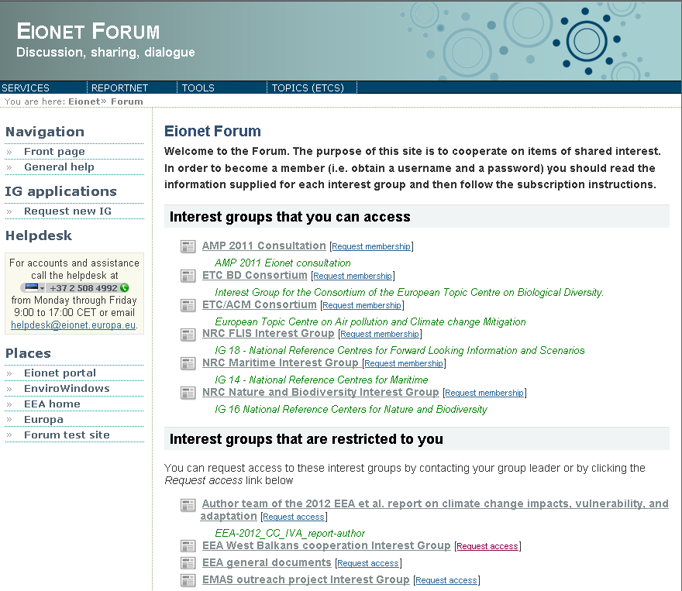Figure 1: Eionet Forum Overview
In the following chapters, all aspects related to content management and users management in an Interest Group will be dealt with.

Naaya overview
Naaya (http://naaya.eaudeweb.ro) is an open source portal toolkit with support for content management, multilinguality, syndication and friendly through-the-web site administration for webmasters with all kinds of technical backgrounds.
Naaya portals target users are people that want to quickly start a website and reduce to a minimum the need to refer to technical system administrators for its update and maintenance. They can delegate authority for content management and local administration to a team of non-technical contributors.
Things like access statistics, mapping domain names to the portal, running jobs at regular intervals, updating the software on the file system or installing new modules still require technical intervention, but these are not daily tasks and are usually taken care of by the network administrators.

Extensibility
This platform has been built in a flexible way, which allows:
- adding other components from the Zope open source community,
- replacing various modules to fit custom needs or
- enhancing existing components to comply with emerging Web standards or respond end user demands.
So, if you are working on a Naaya portal and need a functionality which is not included in the standard package, it is very likely that somebody has already written an open source component for it (e.g. a blog product, integration with external databases); if this is not the case, an additional component can be developed and added to Naaya.
In comparison with other similar systems such as Plone, plugging generic components or integrating existing ones is quite straight forward and does not require extensive knowledge of the Naaya design and architecture.
Components such as the Yahoo-based maps were re-used in the EEA's website (which is built in Plone) after their initial implementation in Naaya. Reusing open source components from one system to another leads to low development costs when it comes to new functionality and allows the portals who use them to stay updated with modern technology and standards.

Modularity
Naaya has been built over the years, following the user requirements gathered from several communities, but its features prove to be quite typical for most modern portals. Since various networks of portals as well as stand-alone applications are powered by Naaya, it is bound to contain very specific functionalities at some point.
That is why Naaya portals are based on a core set of generic modules to which a custom component can be added, in order to overwrite some functionality or add features only required in that context. The Eionet Forum is one of this cases.
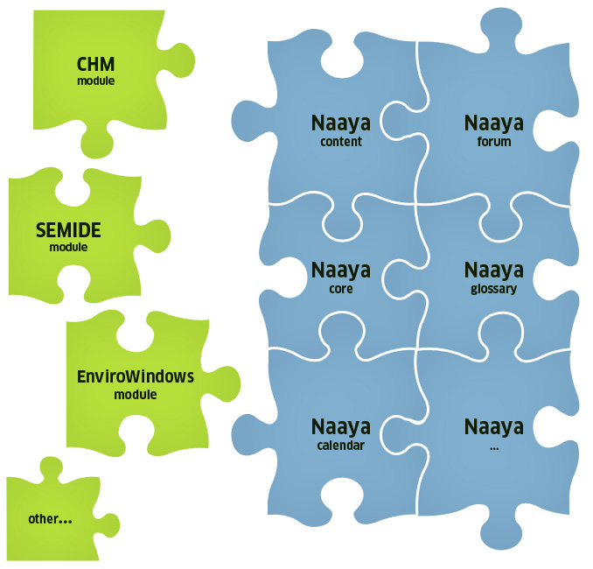Figure 2: Naaya - plug and play components
A special advantage is that, after creating multiple portals on the same Zope server, one can individually customise each portal. Among others the layout, the wording on the forms, the portlets, etc. can differ. New functions can also be written for each portal.

Levels of administration
The administration and maintenance of Naaya websites can be done from the ZMI (Zope Management Interface) by users having the Manager role in the portal. However, this management console is meant to be used by people with technical backgrounds and with a certain level of Zope knowledge.
Therefore, an Administration area is provided to facilitate users with the role of Administrator to make basic maintenance operations and customisations of their portal. Administrators are intended to be users with full decisional rights over the content and presentation of the portal, but not necessarily technical people.
The rights granted to an Administrator are included in the ones granted to a Manager so, when a person has the Manager role, there is no need for him or her to also have an Administrators role.
You can reach the Administration area by selecting the Admin option from the top services links list after logging in with the proper rights. In here, all functionalities are listed in the right-side Administration portlet.
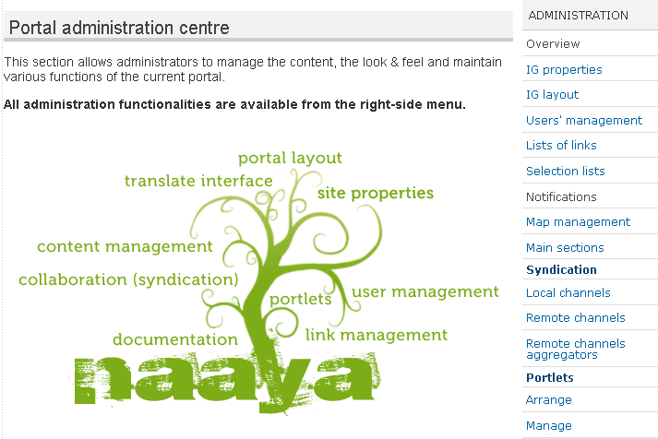Figure 3: Portal administration area
Basically, all operations available from this administration centre are presented inside portal pages and therefore are easier to use because the sense of navigation in the website is maintained. Moreover, each page contains explanatory texts to guide users in executing the operations and help them understand the impact each operation will have to the portal.
On the other hand, the ZMI offers a much wider range of functions, such as undo operations, database (ZODB) management, refined modifications to each Zope object, language management, administration of glossaries and thesauri, etc. For a basic understanding of Zope’s mechanisms and of the ZMI operations, read the online documentation at http://www.zope.org/Documentation/. The Naaya-related objects and operations that can be performed from the ZMI will be partially explained in this guide.
If you are logged into the system as a portal manager, you can reach the ZMI by typing the site URL followed by “/manage” in a browser:

http://<portal_url>/manage

Figure 4: Zope Management Interface
Further in this document, all sections that are addressed to the Managers will be marked with the following formatting:
Example text for the Managers

Content management
Before explaining the operations that can be done upon the content, let's take a look at the content types available by default in the Eionet Forum. As explained before, new types can be created and added as needed.

Content types
When you have a piece of information that you want to see published in the portal, the first step is to decide what type of content would better accommodate it. It is important to put the data in the right format because each type of content has a different set of attributes which can later be used to correctly index and categorise it.
All types have a common set of attributes that generically describe resources. They are called metadata. Since fully defining a resource implies generically describing it and also describing its custom characteristics, all Naaya content types have:
- a common set of properties (e.g. title, description, release date, contributor);
- a custom set of properties (e.g. location for events, expiration date for news).
Administrators can view and configure all these attributes, or properties, in the Administration area. It is also here that they can decide whether the content types available in the portal can be geo-tagged. Depending on the setup chosen by administrators – in terms of geo-taggable content types – such content types can be geotagged by users. When editing a geo-taggable content type, a user has to fill in the Geographic location of that photo. A more detailed description on this can be found in Chapter 12, Photo Gallery.

Folder
Folders are containers of information, similar to the ones from the operating systems. They also have metadata attached, in order to help describe and the index the data inside them.
Throughout this user guide, folders will be also referred to as sections.
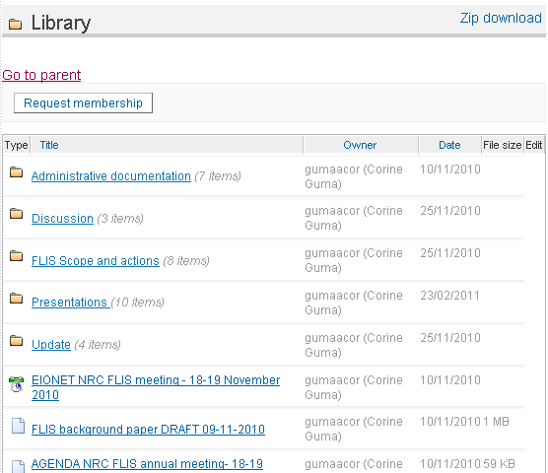Figure 5: Folder structure in an IG Library

HTML document
Use this type to build a generic Web page. A friendly editor will help compose the pages, without you having to actually write HTML code.

The HTML editor
Here's a list of operations that can be performed using this interface:

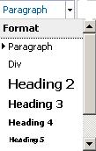 | choose the formatting of the selected text using the existing, predefined tags:  - paragraphs (usually contains an idea, separated visually by a space before and after it)  - div (rectangular box containing text and images)  - headings (each page must contain one and only one heading 1, which is the title of the page, put automatically by the application. Therefore, you can choose between headings 2 to 6.  - blockquote (a block of text containing a quotation of somebody's words)
- choose the text appearance and size from the given lists.
Note: by default, the appearance and size of the fonts are the ones defined in the portal layout and are the same throughout the entire portal for each element. This gives portal visitors a sense of consistency. Changing these attributes of the text should be done rarely and for good reason. Remember that writing for the Web is not the same as writing for print and that different users have different means to see the web page (different screen resolutions, mobile phones, smaller monitors, speech interpreters, etc.), so the pages must scale nicely and be accessible to everybody.
- select the text and make it bold, italic, underlined or strike through
- align the text to the left, middle or right sides of the page
- make ordered and unordered lists
- align text more to the left, middle or right sides of the page; the last option allows you to justify the text, meaning stretch it until the end of the available area
- insert/edit anchor, insert/edit link and remove link buttons.
Anchors are points in that same page (usually sub-headings) to which visitors can jump for easy navigation (e.g. “Top of the page” or “Next chapter”). They are used in long pages, to avoid the need to scroll. The insert/edit anchor window allows you to enter the name of the anchor. Remember the anchor name needs to be unique inside a page.
For the links insertion or editing you must first select the text you want to appear in the link or that you want to unlink. The link button opens a window that allows inserting the desired URL and a title for it, but also select an internal link from the sitemap:

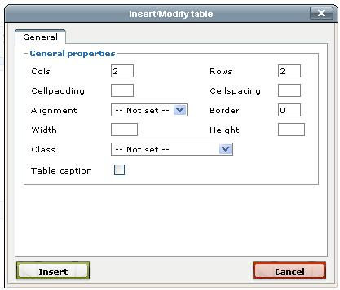
- insert tables and customise their appearance. First click the “Insert a new table” button (first in the list) and choose its various generic settings:
After the table appears in the area you are editing, the rest of the table-related buttons will be enabled. When you move away from the table, those buttons will be disabled again. Clicking inside an existing table will re-enable these buttons.
You can:
  - set the table row and cell properties
  - insert a row before or after another
  - delete a row
  - insert a column before and after another
  - delete a column
  - split columns
  - merge columns
- insert horizontal rule in the current location
- removes formatting from the selection; especially useful when pasting text from another source, such as MS Word or another Web page, and you want to remove the different styles copied from the other application. However, this button is not able to remove all formatting, especially not from the Microsoft applications which have their own embedded styles. For a complete removal, use the “Paste as Plain Text” button (see below).
- makes the selection to be subscript or superscript
- the “Paste as Plain Text” and “Paste from Word” buttons are meant to remove the “bad” code copied along with the text. Pasting text copied from other applications without removing the initial formatting has the following downsizes:
  - the text might not maintain the level of accessibility provided by Naaya applications. By accessibility it is understood the possibility for users with different browsers, types of devices, operating systems, different internet connections and so on.
  - the pasted styles might not match the ones used in the current site
  - the result of mixing the original styles with the local ones can create unexpected results
Both these options open a small pop-up window that allow you to paste the text and click “Insert”. The system will then do the necessary cleaning of the code. The first one is the safest as it removes ALL styles and formatting, while the latter only removes a part of them and preserves things like alignments, paragraphs and colours.
- change the font colour for the current selection
- change the background colour of the current selection
- inserts or displays an image. For a new image, just click on this button from after you ave positioned yourself in the desired position in the text. In order to change the settings of existing images, first click on the image to select it and then click on this button.
This button opens a pop-up window that allows you to specify the URL of an image. If the image is located outside your website, just put the external URL. If the image needs to be uploaded from the local computer, use the Computer tab to upload it and then click on it from the list below. If the image is or should be local, then you can push the little button next to the “Image URL” field, Browse:
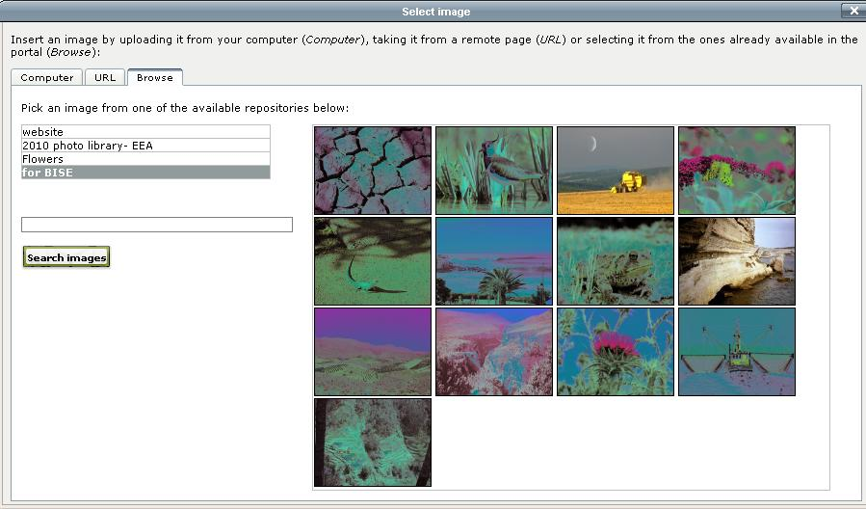
When you select the Browse tab, a list with all available picture albums will be displayed. You can select an album, and you will be shown all the pictures inside that album. Select a picture, click on it and you will have it available in all sizes. You will then select the required picture size, by clicking on the “Save size” button.
Once you've made your image and image size selection, you can proceed to the following step, which is defining the customize attributes, and fitting the image in the text.
You need to provide an alternative description of that image in order to make its content accessible to people with disabilities. The image description is also for the better indexing of your portal pages. It results in better searches when using the internal search mechanism or in external engines such as Google.
The final step is to prepare the image, by setting its title, alignment (left, right, baseline,bottom, middle, etc.), dimensions, vertical and horizontal space, borders, and insert it, as in the figure below:
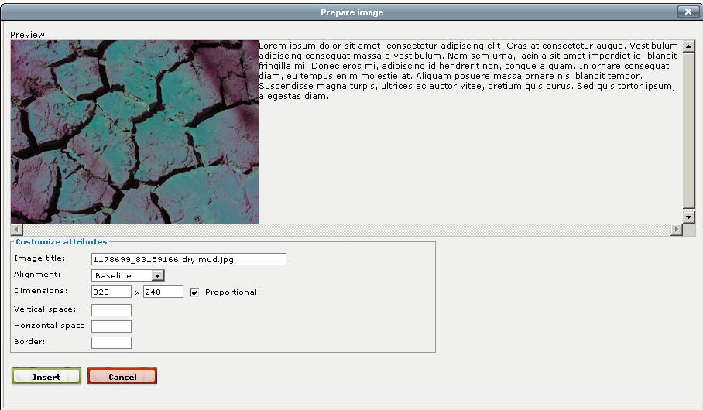
- the preview button lets you know how your text is going to look like
- the “Clean up messy code” removes unwanted formatting
- the HTML button displays the HTML code and lets users with technical background write more complex code.
Please note that the editor removes potentially unsafe code so, if you know what you are doing and want to write some code which is not allowed by the editor for some reason, just disable the Javascript in your browser for a while. Follow these steps to do so for IE:
  - Tools > Internet Options > Security > Custom Level
  - Scroll down to Scripting and disable Active Scripting
  - Click on the OK button
  - Answer "yes" to: "Are you sure you want to change the setting for this zone?"
  - After this refresh the portal properties page
  - The editor icons will no longer be visible.
  - You can then paste your HTML code in the corresponding field (e.g. Description), which is now a simple text area without the editor
To use the Naaya editor again, re-enable Active Scripting.
- the Help button displays online instructions and good practices on using this editor
- the full screen button which allows expanding the editing area on the entire screen. The same button will be than available to shrink back the writing area to the original size. The editor text area is however expandable by dragging the lower right corner until the text area reached the desired dimensions.
You'll notice the description fields of all objects also allow inputting HTML content. Whenever an object is viewed by portal visitors, the description is shown right after the title, so people tend to use a lot of formatting to emphasis certain ideas and to make the paragraphs look nicely in the browser page.

File
A standard file, briefly described by its metadata. Visitors can download it on their computers or view it inside the browser - provided the right plug-in is installed. The file types are automatically recognised by the system in most cases and the corresponding icon appears next to them.
It is possible to store several versions (older versions) of files for user consultation. When editing a file in order to upload a new version of the file, you can also opt for removing some of the existing versions, or simply upload the new version, as shown in the figure below
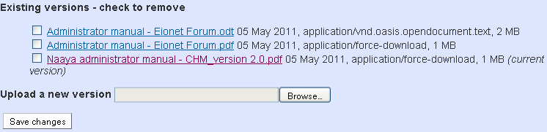Figure 6: File edit form - upload new file
All existing versions of the file can be easily consulted, when clicking on the “Show all versions” link of the file:
An indication of the number of existing versions of a file is given right next to the file, in the folder structure containing that specific file:
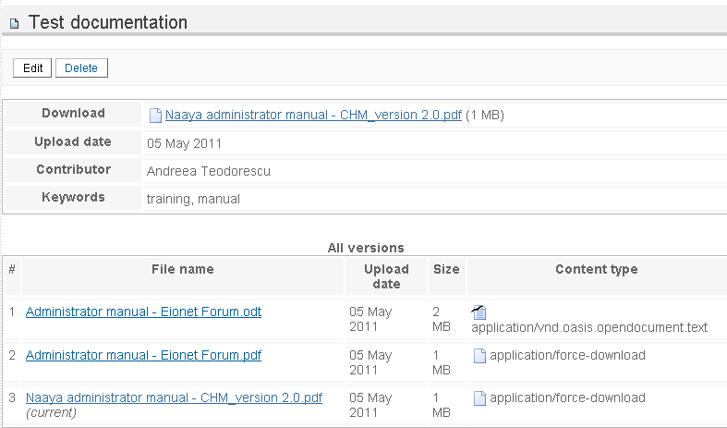Figure 7: File – Show all versions
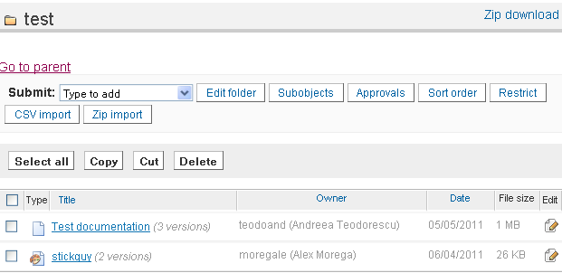Figure 8: File with with indication of versions

News
The news item is a short piece of information with a limited duration of life. Traditionally, news have an expiration date which allows the latest ones to be displayed automatically on the front page and still not have outdated content there.
It is very simple to display news from remote sources of information in the portal pages and also to allow other websites to pick up the latest news from Naaya portals.
You can add a small picture and a big picture in a news item. The small picture appears right after the title, when the news is displayed. A bigger picture can be only added when editing the news, in which case the small picture links to the big picture. This is useful in case you want to offer your visitors a high resolution version of an image, but that is too big to publish directly on the news page.

Event
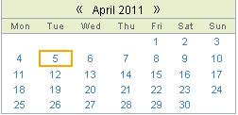Figure 9: RDF calendar
Stores information about an event, a meeting, a conference, etc.
The types of events available are configurable by Administrators
at portal level from the administration area -> “Selection lists” page -> “Event types” list.
Like the news, the events are also syndicated by default and they can be shown under the form of an events calendar. The RDF calendar displays events from various sources of information, including the local portal.

URL
URL objects contain links to remote pages. They are easy to check at regular intervals using an automatic link checkers and can be described by the metadata.

Pointer
Pointers are links to internal portal pages. When adding a pointer, a sitemap is displayed to pick from.

Folder- level
All content is published in folders across the Interest Group, so most of the content management facilities are available from each folder when logged on with a user that has proper rights (see section “Users and roles” for more details).
The full set of possible operations is:
- edit the description of the folder, which will appear on the index page of the folder;
- edit folder properties including its metadata, maintainers emails, allowing user registrations, etc. - “Edit Folder” button;
- define new objects available for that specific folder pushing the “Subobjects” button;
- setting the sort order of contained items (by default the items are sorted alphabetically by title) - “Sort order” button;
- restricting the folder from public view and granting access only to users with a certain role - “Restrict” button;
- CSV import, which allows importing objects from CSV files, following three easy steps: selecting object type, downloading the CSV template for that object type and filling out the rows, and finally uploading the CSV file; please note that the CSV file should be UTF-8 encoded;
- Zip import, which allows importing a ZIP file, in which case a folder will be created from the archive name and the contents of the archive will be represented as File and Folder objects in the newly created folder;
- cut/copy/paste objects from one folder to another (you need to make sure that you still have contribution rights in the target folder and that the target folder allows adding the copies/moved content types as sub-objects);
- delete one or more contained items;
- submit items of the types which are listed in the “Type to add” selection box;
- bulk download, which allows downloading selected files in a ZIP archive to a computer.
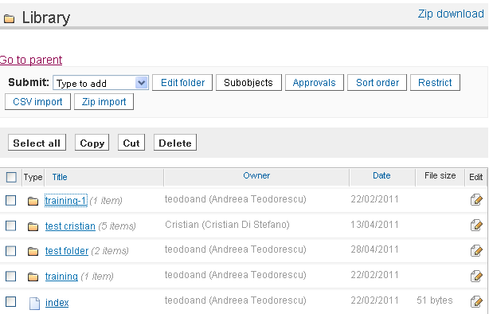Figure 10: Folder view for administrators

Default view and custom index
IG folders are shown to visitors as a listing of contained objects:
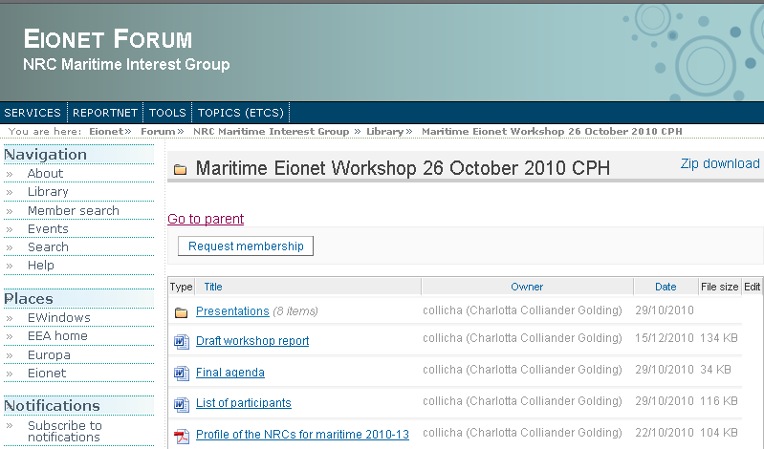Figure 11: Default display of an IG folder
The sub-folders are listed first, then the rest of the objects. Authenticated users with content management rights see more toolbars and links to functionality that they can access.
If you want to add introductory text before the actual listing, edit the folder and fill in its description. Chances are that you sometimes need another display for a folder: e.g. a custom search interface, showing graphs and charts.
In this cases, a Manager can enter the ZMI for that folder, access the “Properties” tab and check the “Use/create public interface” option. Now, a Page Template called “index” will appear in the folder content just in the ZMI, not on the public interface.
It contains a copy of the folder index page written in TAL (Zope's Template Active Language). Managers that have the necessary programming knowledge can modify it to define custom views.
In this manual, the default display of a folder or another object will be also referred to as index.
Only indexes of folders can be customised for a particular item since the need for other types of content to have individually different displays did not come up amongst our users.
In any case, the forms that define how each object is seen by visitors are available to Managers from the ZMI -> portal_forms, under self-explanatory names, such as folder_index, file_index, news_index, etc. Managers can also find here the add and edit forms for all objects in case they want to change something inside. All forms are written in Zope's scripting languages for the interface TAL and METAL.

Comments to content
It is possible to open each piece of content for discussions by checking the “Open for comments” property when editing an item. Subsequently, a button saying “Login to add comments” or “Add comments” will appear to end users when they access that particular item of content.
By default, all visitors that have logged in the portal, regardless whether they have any roles or not, can post comments on items opened for discussions. The comments are shown in the order of their posting. When commenting, it is not possible to respond to a certain posting other that mentioning this in the text.
Administrators see a “Delete comment” button for each posting and, since the user name is displayed for each comment, they can take action (e.g. delete user) in case unwanted comments are posted.

Glossaries as picklists for metadata
The geographical coverage and keywords are part of the common metadata for all Naaya objects - they are actually Dublin Core (http://dublincore.org) elements. There is an important added value from properly indexing the portal content with terms taken from controlled vocabularies, glossaries or thesauri.
Mainly, it leads to better search results from external search engines and the possibility to build guided searches in the portal, where people would be able to pick the search terms from the same glossary or thesaurus used to index the data.
Therefore, administrators can decide to allow content contributors pick from glossary words when filling the geographical coverage and keywords fields for each item. It can be accomplished by accessing the Administrative area -> Portal properties -> Glossaries tab. In this form, choose a value from the “Keywords glossary” and/or “Geographical coverage glossary”.
You'll be given the possibility to choose among the glossaries available in your portal.
By default, no glossary is available in Eionet Forum, but Naaya has support for multilingual glossaries and thesauri as separate products and one can be easily created and filled in with data for you by Managers.

Sub-objects
The list of object types you can add in a folder can be seen in the “Submit” selection box.
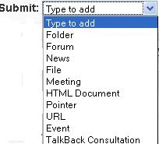Figure 12: Submit content in folders
There is a default set of Naaya objects that can be added in folders, established at portal level (ZMI -> portal_properties -> Subobjects tab).
So, when creating a new folder, content managers will be able to add those kinds of objects. It is also possible to change the sub-objects for each individual folders, also by accessing the ZMI for that folder (after the folder's URL type /manage) and from here clicking on the Subobjects tab.
When changing this list at portal level, only new folders created from that point on will have those setting, they would not be applied on existing folders – it would be rather difficult to make automatic decisions on folders that might have custom lists. If you want to take out or add some content type throughout the portal, a Manager would have to create a Python script that does that.

Interest Group administration
The IG administration area contains a set of forms for:
- setting various portal-level properties such as:
  - metadata – site title and subtitle, description, publisher, contributor, creator, rights
  - logos – Interest Group's logo (s)
  - email settings – containing the mail server used to send mails, the address from which the mails are sent, the list of emails of people that want to receive upload notifications and notifications on errors
  - keywords glossary – the glossary of terms used to index the content by filling in the keywords property of each item.
  - geographical coverage glossary – the possibility to pick a glossary containing the geographical regions and countries, used to fill in the “geographical coverage” property of each item.
No glossary is available by default for EW sites, but a Naaya Glossary can be installed and filled in by Managers, if necessary
  - various other properties relevant for the entire portal:
    - Rename objects' ids – shows the possibility to change the ids of folders' sub-objects
    - Portal URL – the URL your portal is mapped to. Even though your portal might respond to multiple URL addresses, this one should be the official one, used to send notification emails and for the information of system administrators. Before your portal is launched, this property should be empty
    - RDF maximum number of items – the maximum number of items to include in the local feeds. If you don't put a limit for it (aka provide the value 0), channels such as “latest news” can contain a large number of items and therefore burden the server each time they are read by remote websites.
    - Allow switching language for content? - check this item if your portal has more than one language and you have wrongly published items in one language, when you meant to mark them in another. If checked, this option will appear in the edit forms for each item
    - Display contributor name in content indexes – when enabled, the index of all content types will show the name of the contributor who uploaded it.
    - Show how many objects are in a folder – when enabled, the folder index will show how many objects (sub-folders, sub-objects) are in each listed folder.
    - Restrict portal – it denies unauthenticated users access to this portal
    - Is this portal archived? - in case an IG's status is archived, users are no longer able to request access to it
- layout customisation which allows choosing from the existing layouts and colour schemes;
- users' management - allows managing users and their roles from one or multiple user repositories;
- managing the lists of links that appear:
  - in the header and footer of each page
  - in “list of links” portlets
- selection lists – which appear when adding/editing content types (e.g. when adding an event, there is a choice asking for the type of event; these choices can be set in the corresponding selection list)
- Manage Notifications to which users have subscribed, be they instant, daily, weekly or monthly digest
- map management:
  - the “General settings” allow specifying:
    - Center address – the initial centre of the map, which can be a country or a locality
    - Map height – the dimension in pixels you want your map to be appear on the screen
    - Object map width and height – the dimensions in pixels for the small map that appears on each geo-tagged object
    - Map engine – choice between Google / Yahoo / Bing maps; API Keys can be obtained freely from Yahoo or Google;
    - Choose default layer – limit the background choices from the available list - Streets/Hybrid/Satellite
    - The possibility to embed the map in another website
  - Location categories allows the definition of categories used to classify any geo-taggable content within the portal;
  - Manage locations that lists all the geo-tagged objects found in the system, their coordinates and addresses, with the possibility to edit or delete them
  - Duplicate locations form that individuates possible duplicates based on the title, address or coordinates. It is then the Administrator's choice to remove some of them
  - Objects with no coordinates form which lists the locations that don't have coordinates.
- content management:
  - content type management, which allows configuring properties of all types of objects, as well as choosing which content types are geo-taggable.
  - management of the main sections that are listed on the top bar of the layout, but can be also listed on the portal left side as a portlet
- syndication - allows defining and managing local and remote channels in Atom, RDF formats;
  - also lists the remote channels aggregators that can be defined by the portal administrator, which are collections of remote channels that contain all the data from the channels defined in the Remote channels section.
- portlets - define, edit or delete them and arrange existing portlets around the pages
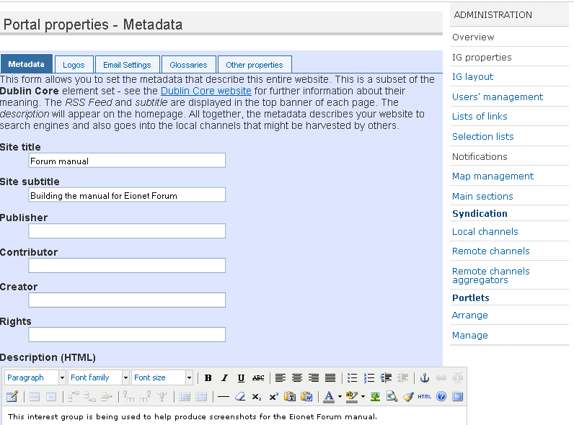Figure 13: Administration area, portal properties, metadata editing

Translate the website
Naaya portals are multilingual in terms of interface, content, search and syndication. Initially, the only available language is English.
Managers can easily define additional languages in which the portal can be translated by using the Zope Management Interface. Add/remove languages operations can be done by accessing the Languages tab of the portal_properties object from the root of each Naaya portal;
Also from here, the default language of the portal can be set. Once a language is added or deleted, this is immediately reflected around the portal interface and content.
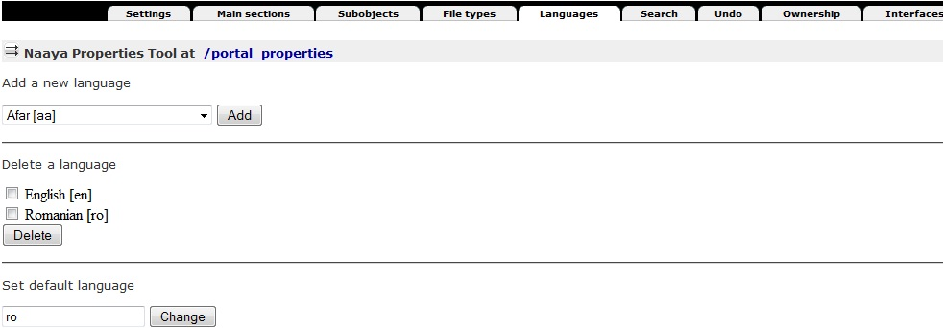Figure 14: Languages tab from portal_properties (ZMI)
All Naaya portal pages are encoded in UTF-8(Unicode) which means that all characters and signs from any language are supported.

The language negotiation process
Here's the full language negotiation process:
- Navigation language (end user selection)
- Preferred local language (client’s browser or operating system)
- Default portal language
When an end user opens a page from this portal for the first time, a localization process takes place and the Navigation language is set. If any match is found between the list of available languages for the portal and the languages in the browsers preferences, that language is set for the navigation language by default. If more language matches are found, then the first one in the settings of the browser takes precedence.
The end user can manually select the navigation language at any time and from any portal page from the list of available languages. This will overwrite all other settings done automatically by the system:
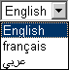Figure 15: Change languages selection box

Multilingual content
All types of content from the portal can be translated in each available language. An item can be added in just one language, which is the content contributor's choice (Posting language field on each submission form):
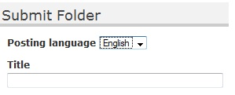Figure 16: Add form for folders
After that, the item can be edited in order to be translated. On the editing form of each item, the “Translate in” banner appears in the bottom of the page and it contains the available languages as buttons, as shown in the figure below:
Here is what happens when a piece of content (a folder, a file, a news item, etc.) is not translated in a certain language:
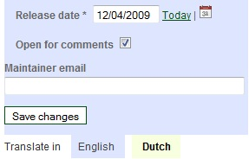Figure 17: Translate content toolbar
- first of all, the system searches for the translation in the portal default language (in this case English) and displays this one if available
- then, the system looks for a translation in the preferred local language (client’s browser or operating system) and displays this one if available
- finally, the system displays the item’s ID
This approach allows users to see that content exists in the portal and, even if they don’t understand the language that item is displayed in (because it hasn’t been translated in the chosen language) or just ID is shown, at least they know that additional data is available and, upon increased interest, they can ask someone to translate the content or they can write to the webmaster and ask for the translation.
Let's take the example of a portal being available in English and Romanian and the default language of the portal is English. If the local settings of my computer are Romanian (for instance the preferred browser language is Romanian or the entire system is installed in Romanian), the selected language will be automatically Romanian.
In this case, the content will be displayed as follows:
- if there is a translation in both English and Romanian of that item, I would be seeing the Romanian one
- if there is a translation just in English, but not also in Romanian, I would see the English version (because English is the default language)
- if only the Romanian translation is available (aka the item was added in Romanian and never translated in English), I would, of course, see the Romanian translations
What if my computer does not have Romanian as an alternative language? Here's what happens:
- if there is a translation in both English and Romanian of that item, I would see the English version
- if there is a translation just in English, but not also in Romanian, I would see the English version
- if only the Romanian translation is available I would see the id of the item and the text “Item only translated in Romanian” appearing next to it, with the possibility to click on Romanian and change the language correspondingly.
Below you can see screen shots of a news item published only in Romanian, in the two conditions described above:
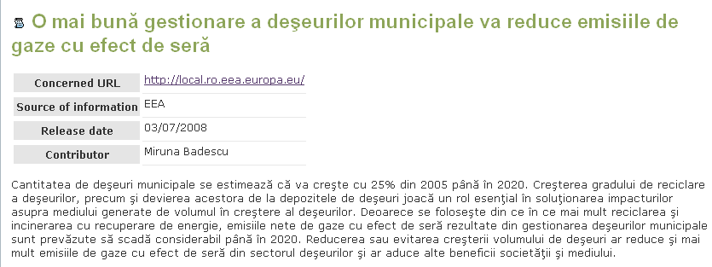Figure 18: News index when the selected language is Romanian
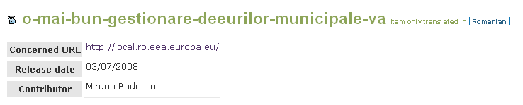Figure 19: News index when the selected language is English

Therefore, it is always a good practice to add items in the default portal language if you don't intend to translate them right away.
Note: not all the properties of content items need to be translated; some of them (e.g. dates, numbers, booleans, email addresses, some URLs) are not multilingual and will be filled automatically for each language on the editing forms.

Multilingual interface
All labels, explanatory messages, lists of links and their descriptions, the portlets (aside from the static ones) and other texts that appear on the user interface can be translated by specialised people into any of the available languages using the Translate messages form available in the administration centre. By default, only Administrators and Managers have the right to access this interface.
The translation centre for the interface lists the messages marked for translation in the portal and users can translate them individually. To ease the translation process, when a message is translated into a language, an OK sign will appear next to it in the language column. A message search is available, which will narrow down the list of messages to those that contain a certain text. Users can sort the list of messages, both ascending and descending: alphabetically or by translation status in a certain language.
                - 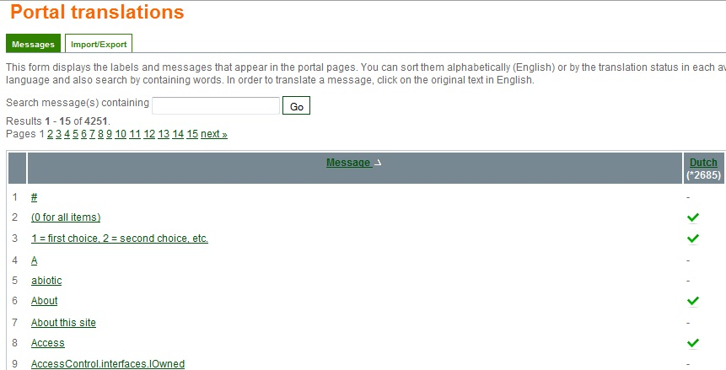– translation selection
                - 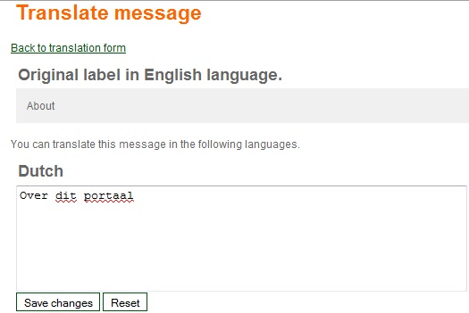– translation form
Figure 20: Translate messages from the administration area
Some of the messages contain HTML tags because splitting the texts around the tags would mean taking some phrases out of their context and therefore losing their meaning. All HTML tags MUST NOT be changed during the translation process.
When the portal has no translation for the navigation language, it will attempt to find one in the languages from the settings of the browser. Ultimately, the translation is shown in the default portal language.
Since the number of messages to translate is high, an export can be made in .PO, .XLIFF or .CSV formats, the texts translated using external tools (e.g. text editors, specific translation tools) and imported back into the portal. Such operation can be made from the Import/Export tab of the Translate messages centre.
The PO file is a simple text file which will be downloaded with texts in English and the target language in which the messages have to be translated, while the XLIFF file is XML and it's very good when the translators use desktop programs that know to navigate among the messages, to suggest translations, search messages, escape HTML tags, etc.

Multilingual searches
The free text search available in the portal is performed in any subset of the available languages on the portal. For each result, links to other available translations are provided.
Figure 21: Multilingual free text search for the SMAP portal

Multilingual syndication
All local channels of information generated in RDF format can be downloaded by end users in the language selected in the browser. Only items which are translated into that language are included in the channel. An item is considered translated into a language if at least its title is translated.
When administrators define the relevant channels exposed by their website, they are able to choose the language in which each one of them is generated. Alternatively, they can choose the “Auto” option, which returns all items, regardless of their translation status in one language, applying the generic language negotiation algorithm.

Change the layout
The user interface for the Interest Group is based on templates for header and footer. The generic page structure is detailed in the image below:
Figure 22: Generic page elements
Modifying the user interface can be done from the administration centre as follows:
- IG properties -> Metadata for editing the site title and subtitle, as well as the front page description;
- IG properties -> Logos for the modification of the top-left and right logos.
- IG layout - for choosing the layout and colour scheme used. By default, the IG comes with just one layout and one colour schemes, but others can be created from the ZMI by specialised people (e.g. Web designers) and later selected from this page
- Portlets -> manage and arrange - allows adding, changing, deleting and arranging the portlets, which are boxes containing information. The portlets can be arranged in the left and right sides of the pages, and in the middle of the front page
Since the content is separated from the presentation and from the data, it is possible to create other layouts by accessing the ZMI -> portal_templates. In here, you'll find the Eionet Forum layout containing templates for the header, footer, left/center/right portlets and the colour schemes. Changing the template requires knowledge of TAL and METAL.
Creating or changing a colour scheme is however very simple for the web designers, since they need to make a copy of an existing one and edit the CSS files and/or replace the few images used in designing the template.
For each portal, new layouts can be created and the existing ones can be changed from the Zope Management interface by entering the portal_layout object from the corresponding IG object. The easiest way to create a new layout is to copy the Eionet Forum one and to start modifying the ‘Naaya Template’s inside:
- portlet_center_macro – the template for the central portlets that appear on the front page
- portlet_left_macro – the template for the left-side portlets
- portlet_right_macro – the template for the right-side portlets
- site_footer – the dynamic page footer. Since Naaya Templates are XML documents, all opened tags must close and vice versa. That’s why this page also contains a dummy header area which only opens the tags that are closed in the actual footer. The two parts are separated by the string
<!--SITE_HEADERFOOTER_MARKER-->
- site_header – the dynamic page header. For the reason described below, this template also contains a dummy footer area which only closes the tags opened in the header; the tow areas are separated by the string
<!--SITE_HEADERFOOTER_MARKER-->
This offers a consistent look and feel throughout the entire site and gives visitors a sense of place and easy navigation.
Naaya websites are compliant with modern web standards such as:
- the website pages conform the Web Content Accessibility Guidelines 1.0 priority 2 (WAI-AA) for the end user interface
- the pages corresponding to the administrative areas of the portal are compliant to the Web Content Accessibility Guidelines 1.0 priority 1 (WAI-A)
- pages validate XHTML 1.1 Transitional
- the mark-up respects the semantic HTML rules
- the Cascading Style Sheets respect the CSS2 Specification
- the portal has a user-friendly interface built with respect of the most important usability principles
- the website is usable in any web browser
- the site information is accessible to all users (including users with disabilities), to all types of devices (different browsers, PDAs and mobile phones, TVs, speech synthesizers, Braille interpreters, TVs, printers, etc.) and to search engines.
The IG has different display versions for print (contains only useful content and ignores navigation elements). Try printing a page without making any choices or additional settings from that page or browser.

Portlets administration
The division of some parts of the layout into portlets is made available for its easy customisation by the Administrators, who can create and move around boxes of information that are relevant for that particular portal.
Portlet assignments are configured from the Portlets -> Arrange administration page. In order to create a new assignment, select its position, the portlet, whether it should be inherited, and then select its location (e.g. a folder). It is also possible to change the ordering of existing portlets by clicking and dragging the colored "position" field in the assigned portlets table. In this table, administrators can also choose not to have displayed certain portlets, by pressing on the “Remove”button.
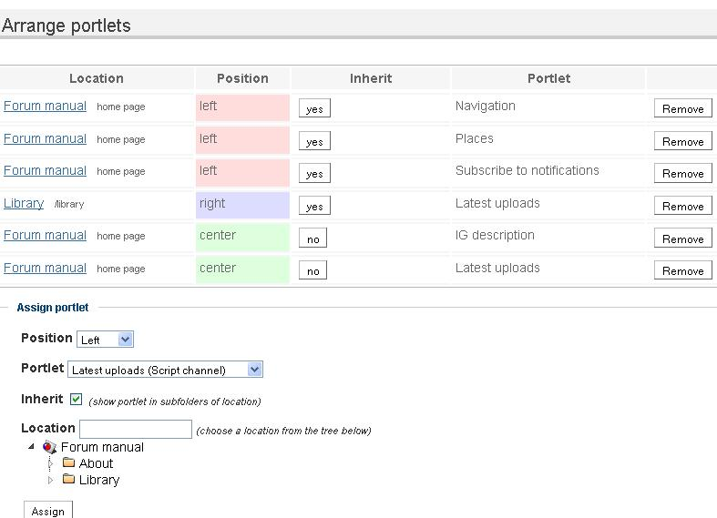Figure 23: Portlets: “Arrange portlets” form
In the “Arrange portlets” form, administrators can choose where to display portlets. Portlets can be shown on the left side, right side, or center (below the page content). Portlets can also be assigned to the entire portal or to a folder, and they can also be inherited (shown also in sub-folders) or non-inherited. For example, assigning a portlet on the site, non-inherited, will cause it to be shown just on the homepage, while assigning the portlet as inherited will display it on all pages in the site. There is a further restriction: right-side and center portlets are only shown on homepage and folder index pages.
Note that portlets inherited from parent folders will always be displayed above portlets in sub-folders.

In the Portlets -> Manage administration page, it is possible to create several kinds of portlets. There are pre-defined templates for remote channel portlets (which display syndicated news/events from remote RSS feeds), local channel portlets (same for locally-generated feeds), folders (showing the contents of a folder), lists of links (showing links defined from the Administration -> Lists of links page). Administrators can also create portlets with static HTML content.
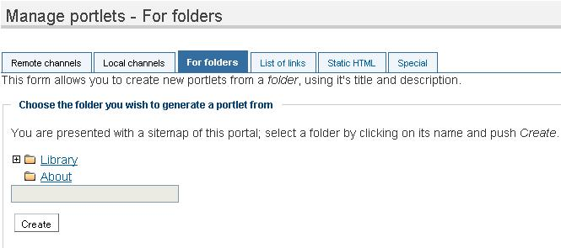Figure 24: Portlets: “Manage portlets” form, For folders

Users and roles
Three concepts govern the security mechanism in Zope and therefore in Naaya portals:
- Users - similar to the ones in operating systems. The user accounts have a case sensitive username and password; in Naaya, additional information is also attached for easier tracking (names and email address).
- Permissions - define granular rights that users might or might nor have. Permissions are not granted directly to individual users, but to roles.
- Roles - groups of users that receive the same set of permissions; after a role is defined, users are “granted” that roles either on the entire portal or just locally, on one or more folders. For instance, all users having the role of Contributor on the entire portal can submit content to the portal.
The security model of a Naaya-based portal is based on the concept that what you see is what you can do, meaning that whenever a user sees the link to an operation, he/she has the necessary rights to execute that operation. By default a set of roles are defined:
- content Contributors - only allowed to add content
- Administrators - can execute all operations available on the portal pages and administrative area, but not enter the ZMI
- technical Managers, with full rights to execute any set of operations
The list of roles can be tailored according with each specific portal needs, taking into account the wideness, skills and availability of the community that provides content and administrates the website.
Once users are defined in the system (have an account), they might be granted with any subset of the above roles (obviously having the Manager role eliminates the need for additional ones) on the entire portal or just on the locations (folders) they need to perform the operations that fall under their areas of expertise.
In an IG, two types of users are defined:
- local users
- Eionet users – which have accounts in the Eionet LDAP directory
Aside from users, Eionet groups can also be granted roles in an IG.
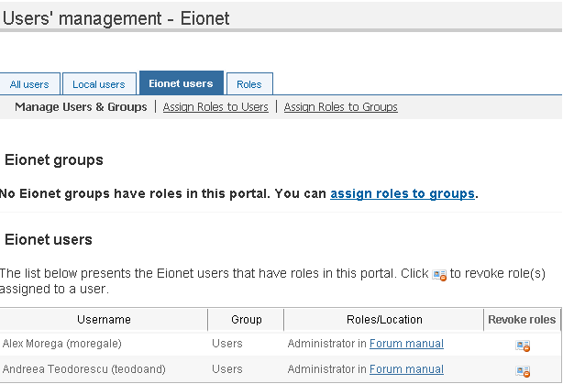Figure 25: Eionet users management
You can easily look for Eionet users, if you want to grant them roles in your IG, following the link Assign Roles to Users, in the Eionet Users tab, either by full name, or part of it.
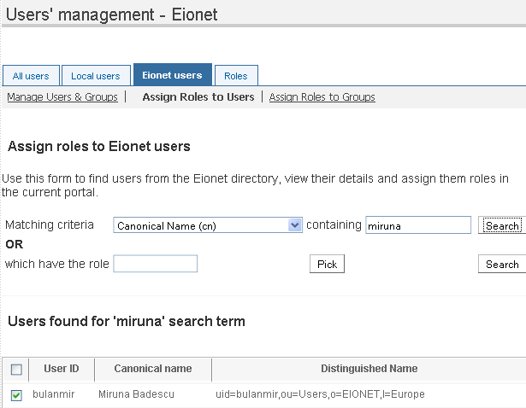Figure 26: Eionet users search
Once found, a user can be granted a role in the IG. Both Eionet and local users can be granted a role, either on the IG level or just on a specific folder level.

As mentioned above, aside from assigning roles to local and Eionet users, roles can also be assigned to Eionet groups. As in the case of Eionet users, assigning the role to a group starts by searching and identifying the targeted group, from the following form:

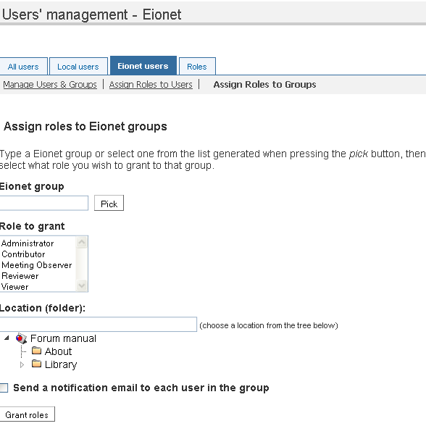Figure 27: Assign roles to Eionet groups
In the Assign roles to Eionet groups page, pushing on the Pick button will reveal the available Eionet LDAP group out of which a choice will be made. Once chosen, an Eionet group will be granted a role in an IG group, and an administrator can choose whether to send a notification email to the Eionet group's users or not (by checking or not the option).

Roles and permissions
In an Interest Group, all defined roles, as can be seen in the below figure (29), are configurable, when editing them, in the sense that permissions associated to a role can be added or removed by an IG administrator.
New roles can also be defined and added to each IG, but it would be highly recommended to create new roles only if really needed.

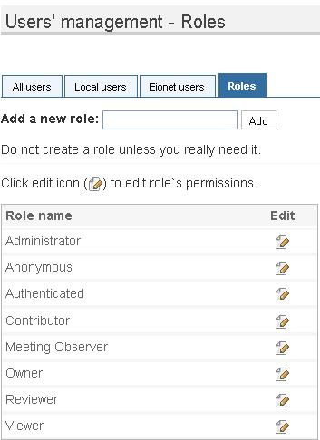Figure 28: IG roles

Discussion forum
The forum is a place where users can exchange ideas and carry on discussions on various topics.
The administrators will open up different topics and invite communities to share opinions on each one. Depending on how sensitive the information is, it is possible to restrict some of the topics for particular groups.
When editing a forum, Administrators set the title, a short description of the forum, define the forum categories (ex: biodiversity), and can limit the size of the uploaded files. Also on forum level, Administrators define the permissions for the forum: add /modify message, modify topic, access content.
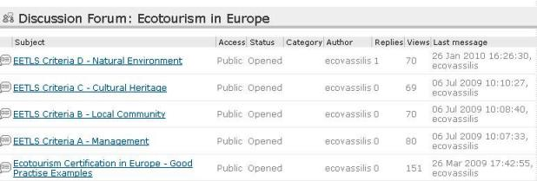Figure 29: Example of Discussion forum
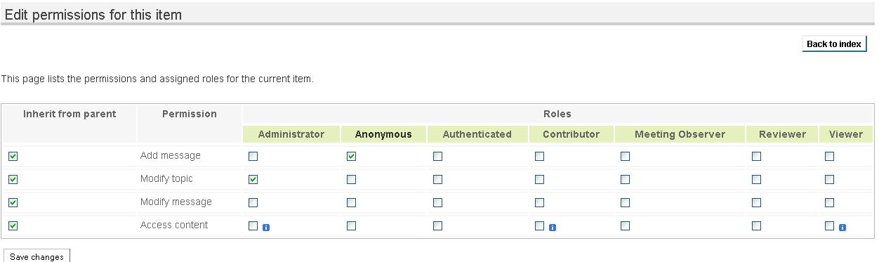Figure 30: Editing forum permissions
IG administrators get to add, delete and edit topics. When adding a topic, the topic subject is defined, its category, and a file can also be attached, supporting the topic. Administrators also get to choose to be notified by mail of all postings on that topic. It's possible to close a topic, in which case people cannot comment any more.
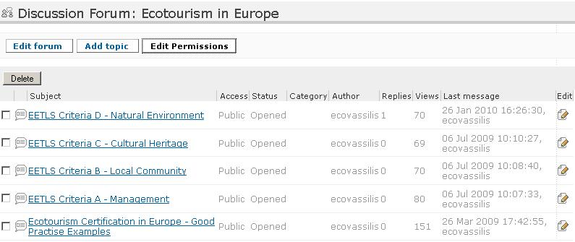Figure 31: Administrative functions of the forum
Inside a topic, the description and its attachments (optional) are the start of the discussion. Users that have the permission to answer that topic (by default Authenticated users) can post a reply to:
- the entire topic or
- someone else's answer
The administrators are able to delete certain answers and even to edit them, this way acting as topic moderator.
When new postings occur in a topic, notifications are sent to the owner of that topic.

Meeting registration tool
A meeting is an object usually stored in a “Meetings” folder, where all meeting information (title, date, location, contact person, etc.), as well as information related to the participation to the meeting, meeting documents and follow up exchanges are stored.
A meeting object can be added by selecting it from the submit combo box, and in the meeting page, the following information has to be filled in:
- Title: meeting title without any additional information
- Description: abstract and purpose of the meeting (optional); the text will be displayed when meeting page is open, right below the meeting title
- Geographical location: displaying meeting location on the map
- Geographical location type type: of the meeting (usually “Conference”, “Meeting” or “Workshop”)
- Keywords: words describing the meeting (words which can be used to search for this meeting on the website)
- Release date: meeting release date
- Start date / end date: meeting start and end date
- Organization/Building/Room: information needed to identify the actual place where the meeting is held inside the building
- time: meeting start time
- Allow people to register to participate: if the checkbox is selected (it is not selected by default) it allows online registration to the meeting. The meeting organizer has to be aware that he/she has to unselect the checkbox when the registration is finished
- Restrict user access to the contents in the meeting: the checkbox is selected by default – by unselecting it you allow everyone to access the meeting’s documents despite the existing access restrictions
- Maximum number of participants: how many people can attend the meeting (usually limited by the meeting room capacity)
- Contact person: name of the person that organizes the meeting, uploads meeting documents, manages participants
- Contact email: email of the contact person, which will be seen in the meeting index page
- Link to the meeting survey: meeting survey for the participants (it should not be set during meeting add, but after creating the survey)
- Survey required: check if the survey should be required to view the meeting index page
- Link to the meeting agenda: meeting agenda (the agenda is viewable by everyone, not only meeting participants)
- Link to the meeting minutes: meeting minutes (it should not be set during meeting add, but after uploading the minutes file).
Adding an agenda, meeting minutes and survey
As previously mentioned, the meeting object is also a folder object. This means that administrators can add other objects to it, just like to any folder. Some examples can be agenda, presentations, meeting minutes and survey for the participants. For faster access meeting agenda, minutes and survey can be displayed as icons in the meeting index page.

Managing meeting participants
Meeting participants are people taking part in the meeting. They can access meeting documents and they also have rights to fill in meeting surveys. Meeting participants can be managed in two different ways:
- the meeting administrator can beforehand add meeting participants with EIONET or local account.
- meeting participants can register to participate in a meeting if online registration is activated by the administrator. The meeting participants list is stored in the meeting index page and can be exported to MS Excel, if needed.

Adding meeting participants
In order to add meeting participants the administrator has to open the participant management page by clicking ‘Participants’ icon in the meeting index page.
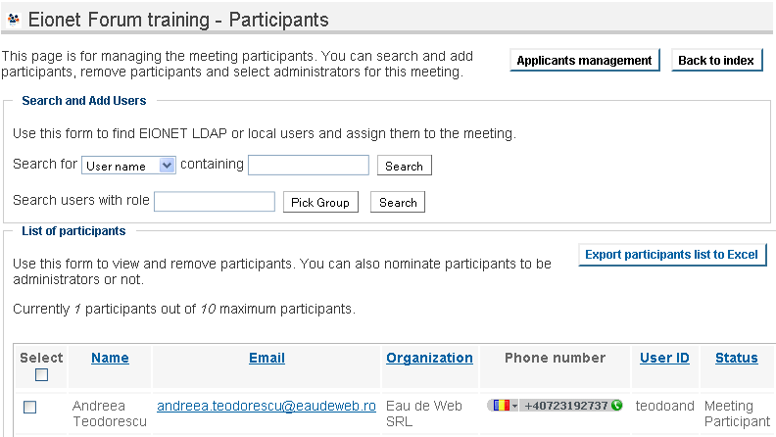Figure 32: Adding meeting participants – Search and Add users
Once users are found their names and usernames are displayed on the screen. The administrator has to select the users and press ‘Add selected users’ button.

Registering to participate in a meeting
On-line registration to participate in the meeting can be activated by clicking “Allow people to register to participate” button in the meeting edit page. The “Register to attend” button will appear in the meeting index page:
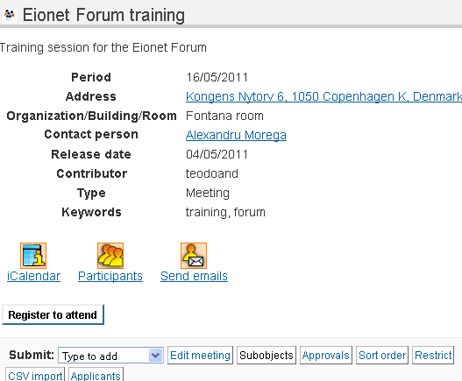Figure 33: Register to attend a meeting button on index page
In the Participants page, aside from the possibility to add meeting participants, administrators have access to the list of participants, which they can manage. The list of meeting participants can be exported to an Excel file.
Administrators have the option to send emails to the meeting participants, and the meeting contact email is used as default for the sender address.

Adding meeting observers
In order to manage the access to meetings and meeting documents to selected EIONET users that are not necessarily participating at the meetings, but still need permanent access to meeting documents, a Meeting Observer role has been created. Granting permissions to these users, as well as further information on users and roles in an IG can be found in chapter 8, Users and Security.

Meeting reports are available, and they display the organizations or the people that participated in a meeting.

The survey tool
This component lets content contributors create surveys that both authenticated and anonymous users can take. A survey is a research instrument consisting of a series of questions for the purpose of gathering information from respondents. The respondents are usually part of a community with relevant knowledge in the area of interest of your survey and they can be from a restricted group (authenticated users only) or part of the general public.
The answers to the survey can be analysed individually or they can be aggregated as statistics in reports. Both numerical and graphical statistics exist.
A survey can be added inside Naaya folders, just like any other content type (e.g. Naaya Document, Naaya News). Go the folder where you want to create it and click on the Subobjects button. Make sure that Survey is selected in the list of object types, click "Save changes" and then go back to the folder index. This step needs to be done only once per folder if the survey type is not a default data type for the entire portal.
After submission, the administrators can change the survey's :
- metadata (e.g. title, description)
- attachments
- composing questions and
- its automatically generated reports
by using the upper toolbar buttons.
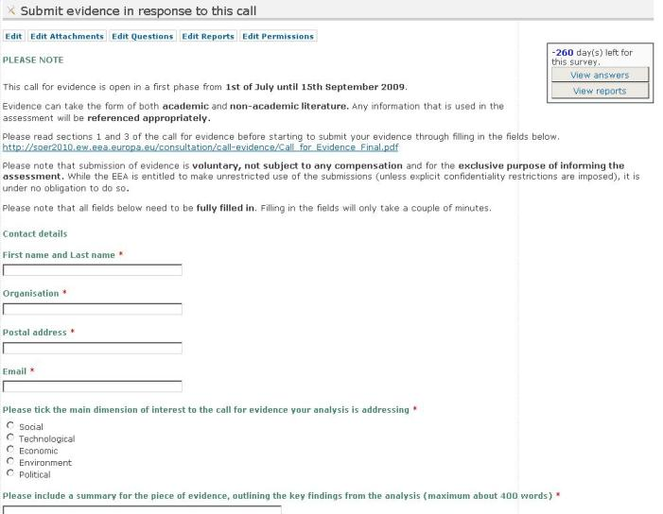Figure 34: the Survey index for Administrators
When editing a survey, you'll notice a few custom properties:

Users cannot take the survey before the release date. The expiration date disables the possibility to take the survey after that date if “Allow posting answers after the survey expiration date” is set to No. This proves useful since it is almost always the case for some (key) people not to be able to respond before the expiration date. In any case, the number of remaining days appears on the survey index and it urges people to respond faster.
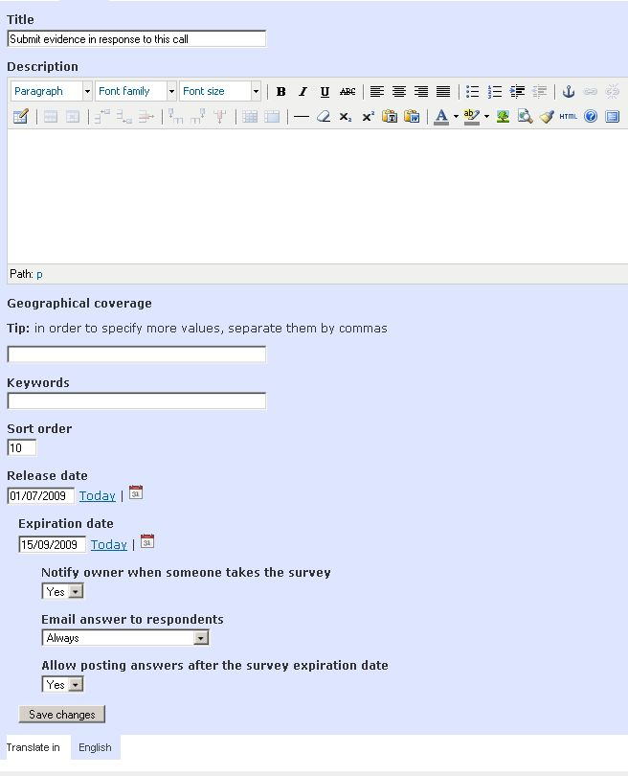Figure 35: The edit form of a survey

Attachments
When taking the survey implies having read some background documentation, the user managing the survey will upload these documents as attachments. When respondents take the survey, the attachments appear at the top of the page (below the description).

Questions
The following types of questions are supported:
- Multiple choice - one answer:
- Combobox
- Radio buttons
- Radio matrix (group of questions with one answer per row)
- Multiple choice - multiple answers:
- Checkboxes
- Checkbox matrix (group of questions with multiple answers per row)
- Single line text (free text input box)
- Paragraph text (multiple line answer, used for longer responses)
- Date (for date type answers)
- File (for letting the respondents back their answers with additional information inside files)
If you need to better describe certain sections of the survey, you can use the "Label" question, which has no answer. The respondent will only see the descriptive text.
After adding a question, you can further customize it (e.g. set the available choices) by clicking on the corresponding "Edit" button, or you preview it by clicking on its title.
To change the order of the questions, change the "sort order" column accordingly and press the "Set sort order" button.
 | 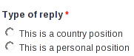
 | 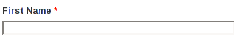
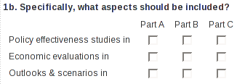 | 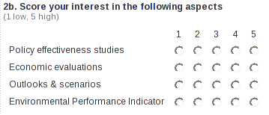
Figure 36: Some question type examples

Radio buttons questions
Sometimes the choices of a radio question might not be enough for the respondent. In this case you can let the respondent answer with their own choice. To do this, go the the edit page of the question and set “Add extra option” to “Yes”. The question will look like in the figure below.
If the respondent chooses the extra option, the choice will appear exactly as he/she entered it in the survey answer and as “Other” in the reports.
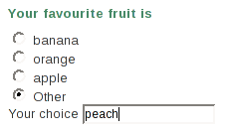Figure 37: Radio buttons question with extra choice | 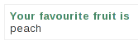Figure 38: Answer to a question with extra choice

Changing questions after the survey was taken
After the survey was taken, only a limited set of changes of the questions are permitted, e.g. the choices from multiple choice questions can't be changed. If no answer exists for a question , then the question can be changed in any way.
To delete the existing answers enter the ZMI and delete all the “answer_*” objects.

Reports
To analyse the answers of the survey by aggregating them, you might need to create one or more extra reports and add statistics to them.
Click on the "Edit Reports" button to go to the reports management section. To add a new report, choose a title for it and click on "Add report". To change its description click on the corresponding "Edit" button. To configure the statistics included in the report, click on its title. Now choose the question that will be included in the report and then what kind of statistics would you like. There are 2 major types of statistics: numerical (tabular) and graphical (charts).
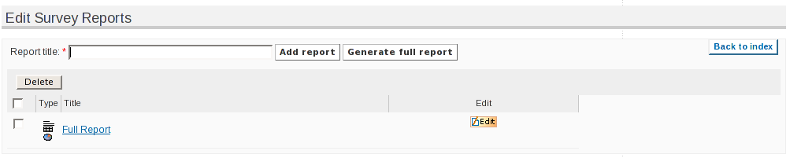Figure 39: Edit survey reports
Because adding a statistic one by one would take too much time for a complex survey with many questions, there is the possibility of creating a complete report with all the question - statistic combinations. To create this report, choose a title and click on the "Generate full report" button.

Email notifications
When a respondent answers, the owner of the survey can receive a notification email, which includes a link to the newly added answer. The notification can be enabled or disabled by using the "notify owner when someone takes the survey" setting.
After a survey is taken the authenticated respondents can receive an email notification with their answer by using the "Email me my answer" setting. In some cases, e.g. short surveys, it is desirable to let administrators disable notifications, while in other cases, e.g. large surveys, notifications should always be sent. This is why, the survey has an "email answer to respondents" setting (for administrators) with the following choices:
- Always - a notification is always sent to respondents
- Never - a notification is never sent to respondents
- Let respondents choose (default is yes) - respondents can choose if they wish to receive a notification; the "Email me my answers" setting will be checked
- Let respondents choose (default is no) - respondents can choose if they wish to receive a notification; the "Email me my answers" setting will be unchecked

Taking the survey
Send the link of the survey to the respondents, so that they can take it.
To prevent spam, a text recognition mechanism (CAPTCHA) is used for anonymous users. Authenticated users are permitted to answer only once, but they can change their answers any time they wish to.

Analysing the results
The user managing the survey can see the individual answers by clicking on the "View answers" button from the survey's page and selecting the answer he/she wants to see. Administrators have the possibility to download the list of answers in the CSV format.
While the individual answers can only be seen by a restricted group of users, the reports can be seen by anyone (if the default settings are used). To view the reports click on the "View reports" button from the survey's page and then select the report you want to see.
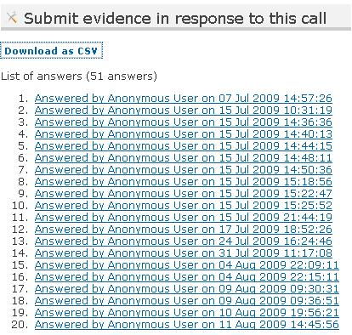Figure 40: List of answers
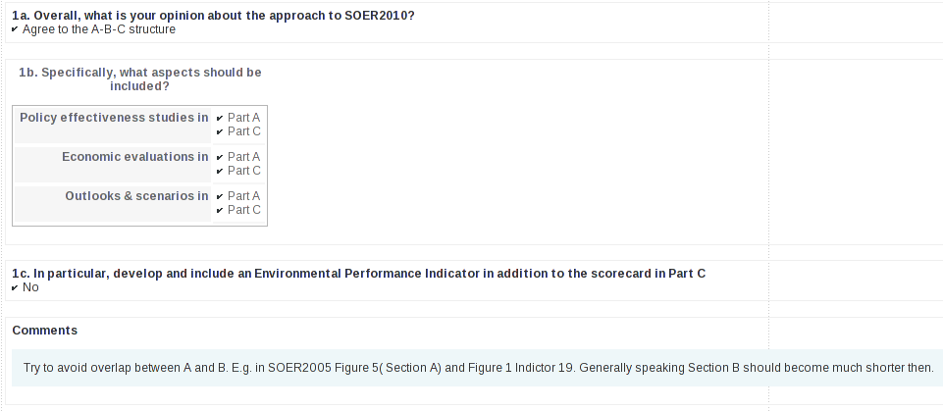Figure 41: Survey answer
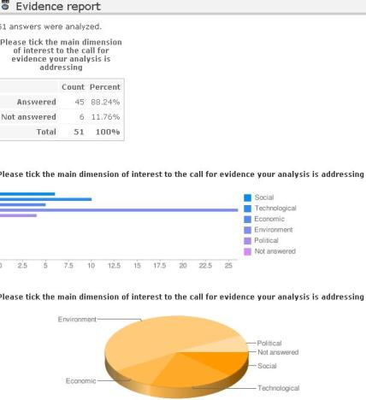Figure 42: Survey report

TalkBack consultation tool
Consultation tools serve in getting feedback on a document from a user community. They allow uploading a file for each portal language, on which users can comment:
- freely, as overall comments
- for each line, in which case case the file must contain line numbers
- by answering guided questions previously defined by Administrators
- by adding files in support to their answers
- by inserting comments directly on the online text
The TalkBack can be used to publish a series of articles and to let users comment directly on the text. Inside a TalkBack the idea is to define chapters like an online book, each chapter being divided by the system in paragraphs on which users can add comments.

When editing the TalkBack item, Administrators can choose from the following:
- Allow visitors to register as reviewers for this consultation – option which adds a link to the registration page for unauthenticated users
- Allow reviewers to upload files when posting a comment – option which enables the file attachment in each comment
- Allow reviewers to invite other people to review
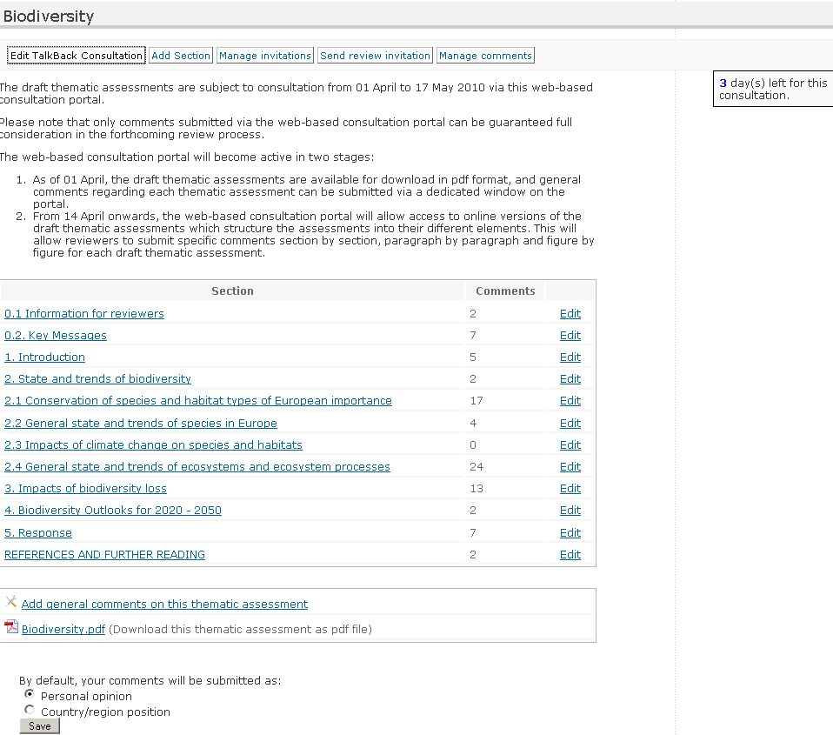Figure 43: TalkBack consultation - Administrator's view
By clicking on the “Add section” button, Administrators can define sections, one by one. The system will split the text into paragraphs, so the text must be either constructed using the HTML editor, or to be clean up first if it's pasted from another application (e.g. Word, PDF). It is possible to do this by using either the “Paste from Word” or “Paste as plain text” buttons of the HTML editor.
The reviewers will then see a button to comment on after each paragraph, as shown in the figure below:
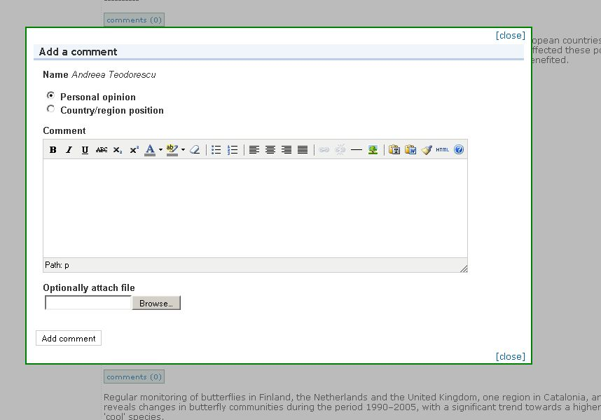Figure 44: Comment on the TalkBack paragraphs
The table of contents is available on the right side of each page and the navigation from one chapter to another can be easily made using the “Previous section” and “Next section”. If users will want to see the other comments previously posted on that chapter, they will click on the top button “Show comments”. Users can both contribute with comments to the consultation sections, and answer to already published comments.
When logged in as Administrator, it is possible to edit and delete comments, which makes it easy to moderate the feedback.
After adding a chapter, it can be edited by Administrators paragraph by paragraph, with the possibility to:
- Split a paragraph into two
- Merge a paragraph with the next one
- Edit the text from a paragraph
- changing the order of two paragraphs, by swapping with next paragraph.
Deleting a paragraph can be done by merging it with the next paragraph and editing the result to remove the unnecessary text.
Aside from the consultation editing, from adding/editing new sections to the consultation, administrators can also create and manage invitations, in the Consultation invitations form, respectively in the Manage invitations tab, from where they can invite people to participate in the consultation.
By using this invitation form, the invited persons will be notified by e-mail with a personalized link, and they will be able to submit directly their comments to the consultation, without the need to register and contribute directly in the portal. After they have contributed with their comments, such comments can be approved, edited or deleted by administrators.
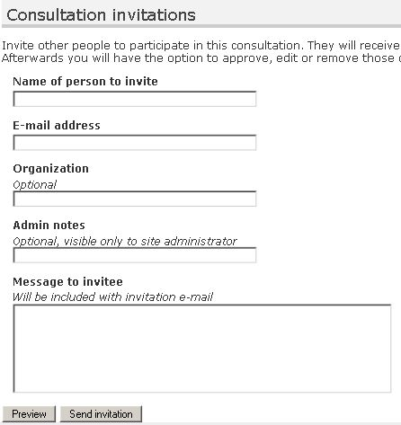Figure 45: TalkBack consultation – Consultation invitations form
These invitations can be managed from the Manage invitations tab, place from where active invitations can be revoked.
When going to the Manage comments tab, the total number of approved comments will be displayed by default, along with the number of unapproved comments and the number of comments submitted as an answer to the invitations sent by means of the Consultation invitations form.

Photo gallery
A photo gallery is a space for image publishing that can contain multiple albums, which contain photos, all described by metadata. Photos can be added either one by one or from a zip file. At album level, visitors can download either all the album photos, or a selection of the album, as a zip file.
One of the album's photos can be chosen as album cover. Aside from this, administrators can add and edit the properties of the galleries, albums and photos.
At photo gallery level, the options available are to define its title, define the key words and geographical coverage, restrict comments on the gallery, as well as restricting the access (when checked) to the original images; available operations are also defining the sort order, cut/copy/paste and deleting certain albums from the photo gallery.
When adding a new album to the photo gallery, administrators define its title, description, keywords and geographical coverage, can indicate specific attributes such as the author and source of the photos; they can also limit the maximum number of photos in an album, the maximum number of photos to be displayed per page, can restrict the access to the original images, can watermark the images with a pre-defined text, and geo-tag the album and its photos. As mentioned above, photos can be uploaded either one by one, or by uploading a zip archive in the album.
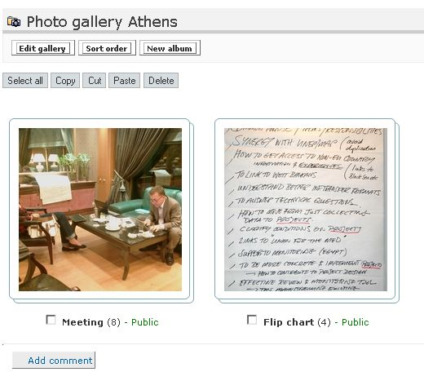Figure 46: Photo gallery - Administrator's view
Editing a photo album allows administrators to define the album's title, fill in a short description, define key words and geographical coverage; they can indicate specific attributes, such as the author and source of the photos, and can also limit the maximum number of photos in an album, as well as the maximum number of photos to be displayed on a page. Restriction to the original version of the photos can be also set here, and photos can be geo-tagged, as well as the whole album, by defining its geographic location on the map.
Albums, as well as their photos, can be geotagged – if this property is enabled for photos, by defining their geographic location. For instance, when editing a photo, you have to fill in the Geographic location of that photo. If you have the specific address where the photo was taken (country, city, street address), you can fill it in in the “Address field” and the application will geocode it, retrieving the associated geographic coordinates for that specific address – latitude and longitude.
Once you fill in the address, paying attention to the information provided, you push the “Center map” button and the location is shown on the map, and the associated geographic coordinates are filled in. If the localization on the map is not as specific as you want, you can refine the result on the map.
You have to pay attention to the way you fill in that specific address – if you provide a too detailed address (such as filling in the apartment number, the floor). Other complicating factors in the geocoding process would be: address standardization variations (for instance, in the case of street names that include numbers, such as “ 1 December Street”, in the address field we should fill it in in numeric format, and not “First December Street”); standardization is also an issue in the case of abbreviations, such as “blvd” which stands as an abbreviation of “boulevard”, “ave” which stands for “avenue”, “str.” which stands for “street”.
Incomplete addresses – which do not include important information, such as the city/town/locality, the country, or ZIP codes, are also an important factor to be considered when trying to match and geocode those addresses.
Incorrect addresses, which contain misspellings or typos – such as wrong street name, wrong city name, would also impact on the geocoding process.
Aside from geotagging albums and photos, you can also watermark the photos of an album.
When editing an album, there's the option to “Watermark images with following text” - which gives the option to watermark the album photos with a certain text.

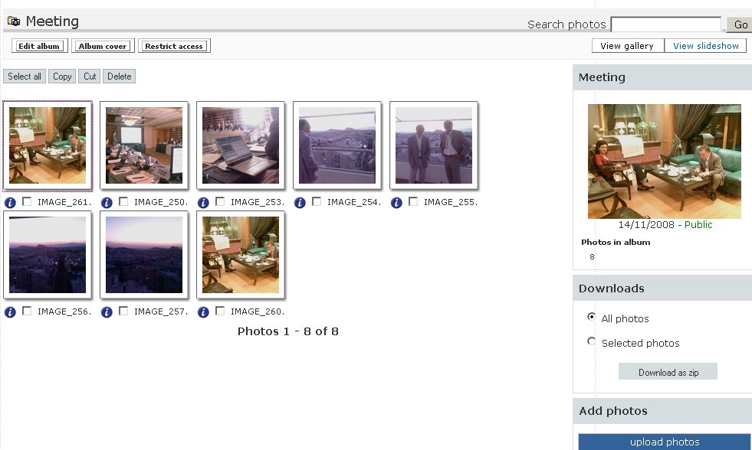Figure 47: Photo gallery album - Administrator's view
The index of an album displays the photos, some of the album's characteristics, the photo number, keywords, geographic location – map, and offers to users the download option, be it either selective, or bulk (entire photo album), as well as the possibility to add new photos to album. At album level, administrators have the cut/copy/paste option, as well as to delete certain photos of the album.
A photo search is available at album level for finding the search string inside the photos' metadata.
When adding a new album, its default status is public, accessible without restrictions to all visitors on the website. Administrators can opt for the Restrict access functionality,which allows restricting access or granting the access to that particular folder to a group of users, thus making the album no longer public.
When photos are uploaded, a few versions of each photo, with different dimensions, are generated: thumbnail, very small, small, medium, large and very large. Visitors see its thumbnail, but can also see, download and use the photo in any of these versions, along with the originals.
When clicking on a photo, visitors can go back and forth to the previous/next one, can see the whole photo album as a slideshow, can access the details and technical information of the photos and can visualize its geographic location.
In the same context, aside form the album navigation, administrators can also flip and rotate the photos using the buttons on top of the thumbnail if necessary, can replace certain photos in an album and geotag them.

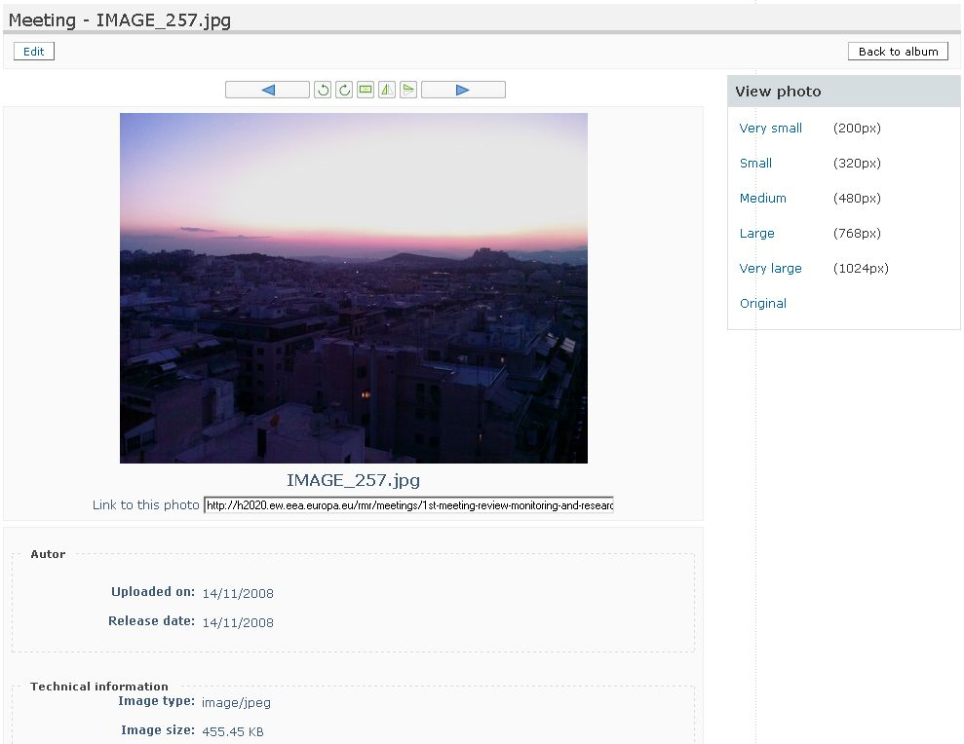Figure 48: Photo navigation - Administrator's view
The operations available for administrators are:
- add Photo Gallery/ Photo Album/ Photo
- bulk upload photos from a zip file
- edit Photo Gallery/ Photo Album/ Photo
- flip and rotate photos
- geotag photos/albums

References
Web Content Accessibility Guidelines (WAI )
http://www.w3.org/TR/WAI-WEBCONTENT/
XHTML 1.0
http://www.w3.org/TR/xhtml1/
Zope documentation
http://www.zope.org/Documentation/

Because either the question did not exist at the time the survey was taken or the respondent did not answer.

